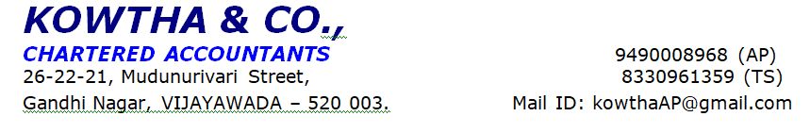
Application No | DB20250213510307
Name of Applicant | XXXX
Name of Co-Applicant
Phone Number | XXXX
Name of Concern | XXXX
Initiated Premises | XXXX
Visited Premises | XXXX
Residential Premises | XXX
Appointment Fixed | 02.55 pm |  | Date of Visit: 21-02-2025
Person Met | MrXXXX
Amount and Purpose of Loan | He applied loan amount of Rs. 90 lakhs for the purpose of business development
Type of collateral | (146SQ.YDS) and Market value of collateral security - 2 cr
Collateral Property Address | XXXXX
About the Applicant | The applicant is XXXXX, he aged 63 years has studied 10 th class and native of Guntur. He is living with his family at owned house.
Family Members | Name | Relationship |  | Age | Education | Occupation
 | xxxx | Mother |  | 60 years | - | House Wife
 | xxx | Wife |  | 32 years | PG | House Wife
 | xxxx | Daughter |  | 10 years | 4 th class | -
 | xxxx | Daughter |  | 4 yeas | - | -

Banking Details | BANK NAME | ACCOUNT  TYPE |  | AVG BAL |  | NO: OF YEARS MAINTAINED
 | Union bank | Savings |  |  |  | 10 years
 | SBI | Savings |  |  |  | 20 years
LIC/Mutual funds | NA
Assets | - Open plat Area- 4 cents Market Value- 1cr Name of the Asset holder ,- Koteswara rao
No. of Loans | BANK | TYPE | LOAN |  | EMI |  | OPEN/CLOSE
 | Union bank | Rental loan | Rs. 72 lakhs |  | Rs.1,00,000/- |  | Open
 | Union bank | HL | Rs. 3 lakhs |  | Rs. 45,000/- |  | Open
Aboutthe Business | - Applicant started business in the year of 2011  - It is sole proprietorship business and applicant is the sole proprietor of this business  - He is running business under the name of M/S. xxxxx  - Nature of the business is trading of poultry feeds (sweet corn )  - He purchases stock from farmers and directly sent to the customers (Poultry farm owners)  - He also purchases feed from local corn dealers  - He is not maintaining stock at business premises, he directly delivers stock from supplier premises to applicant customer’s premises  - He sale monthly 01 lakh kgs of sweet corn feed and he get Each one kg profit –Rs.4/- rupees  - He is running business in owned premises  - 04 workers are working under this business and he pay wage Rs. 60,000/- per month  - Major business transactions are done through cash/bank in his business
Name and Contact number of Regular Customers | - Number - Name ( customer)
Name and Contact number of Regular Suppliers | - Number - Name
Business Activity and stock level observed at the time of visit | No activity seen
Documents Observed | - Not provided any documents
Whether Business Registered under GST? | - Nil
As per Audited individual ITR’s | - Nil
Monthly Gross Receipts | - Rs. 70,00,000.00
Monthly Expenses | - Rs. 66,40,000.00
Net Profit | - Rs. 3,60,000.00
Net Margin | - 5%
Family Expenses | - Purchases, Salaries, Electricity, Transport / Travelling exp, Other exp
Employees | - 04 members
Concerns | - We have verified his savings account where no business transactions were seen.  - We have verified his CC account where the internal transactions were like observed but doesn’t looks like business transactions.  - No business activity was seen in the premises.  - No records, bills, receipts none were provided.
Other observations | - Business name board was seen
Other Incomes | - Applicant receives rental income Rs. 1,50,000/- per month
Neighbor Check | - We got 03 years positive feedback from neighbor check
Status | - Positive

Disclaimer Clause:
This report (including any attachments) has been prepared based on verbal information provided by the person contacted. ARKA FINCAP LIMITED will be solely responsible for any actions taken on this report and any liabilities directly or indirectly accruing from such actions. M/s. KOWTHA & CO will not be held liable in any case.

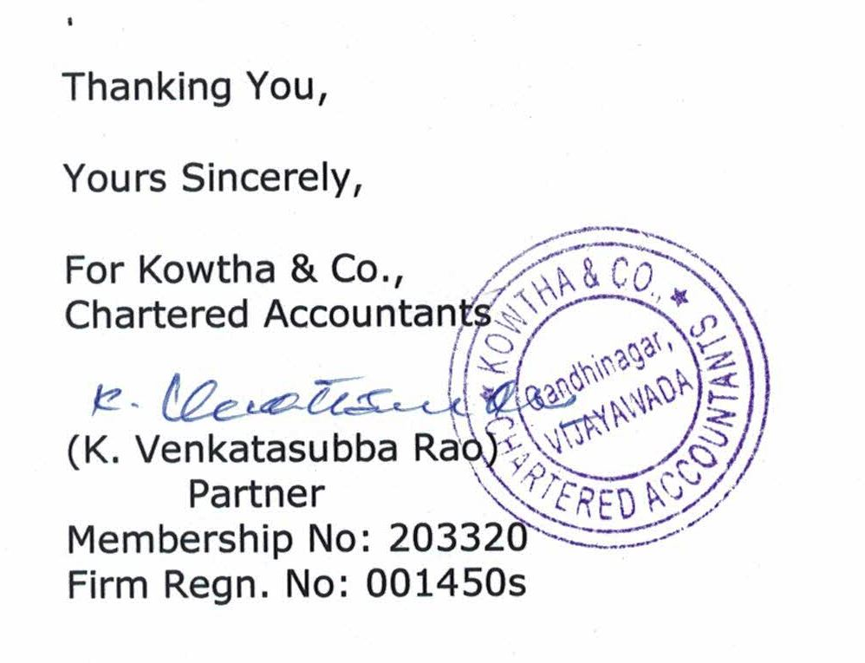

Photos:

